Wheeldon Brothers Waste Ltd 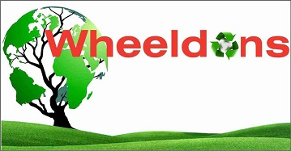

Environmental Sustainability Policy Statement
Wheeldon Brother’s Waste Ltd is committed to a sustainable future by protecting and conversing the natural environment. We accept that we have a leadership role to helping customers gain value by the circular economy, closed- loop thinking which is at the heart of our business. A fundamental shift in our business model from service supplier to resource producer by manufacturing green products and energy, which enables us to meet our customers environmental challenges.

Our strategy for the environment is to achieve a proactive environmental performance in all of our activities so as to protect, conserve and minimise the potential for pollution and the environmental impact. This means in addition with compliance with statutory requirements, we will develop a sense of environmental responsibility within all employees and seek to have that attitude carried out into the community.

We are committed to continually improving our environmental performance by aligning our operations with the principles of ISO 14001 Environmental Management Systems, ensuring compliance, pollution prevention, and the sustainable use of resources

We pursue our commitment to environmental sustainability by:

- Undertaking risk assessments of all appropriate activities, and to specify and implement resultant control measures in order to reduce or eliminate environmental risks:
- Comply with all applicable legislation, regulations and guidelines related to the environmental aspects of its activities and services as stipulated by regulatory authorities and industry bodies.
- Promoting good environmental performance across the business including monitoring, measuring, and seeking ways to reduce and manage our carbon footprint as well as saving natural resources.
- Working in partnership with our suppliers to deliver the requirements of this policy, as a responsible member of the community.
- Proactively working with industry to develop common environmental goals across the general community.
- Providing adequate funding and resources that contribute towards good environmental goals across the general community.
- Improving and assessing our environmental performance by investing in training, awareness, systems, and tools. Monitor our performance and progress against objectives.

I empower all our employees to co-operate and work as a team to improve the environmental performance of our activities and those we provide as part of our circular economy to our clients.

Signature: …………JCW…………… Position ……….…Director ……………….

Date……14/04/2025…………………... Review Date………13/04/26……………

